Prepared for:

Edward B. Muny

Chief Executive Officer

Bull Stock Ticker

1234 King Street, Suite 1000

Toronto, ON M3A A1B

Submitted by:

Sharlene Hopwood

Project Manager

E-Tech Consultant Company

1380 Don Mills Road
Toronto, ON M3B 2X2

Table of Contents

Executive Summary……………………………………………………4
-Purpose of project……………………………………………………6
-Strategic recommendations…………………………………………. 6
-Implementation considerations………………………………………7
-Benefits of the solution………………………………………………7

Design Requirements…………………………………………………..8
-Characterization of the existing network…………………………….9
-Customer requirements……………………………………………...13

Design Solution………………………………………………………..14
Appendixes…………………………………………………………….31
Cost…………………………………………………………………….51

Executive Summary

E-Tech Consultant Company
1500 Don Mills Road
North York, ON
MJ2 4A5

October 24, 2002

Edward B. Muny, CFO
Bull Stock Ticker
1234 King Street, Suite 1000
Toronto, ON
M3A A1B

Dear Mr. Muny,

We at E-Tech Consultant Company would like to thank you for this opportunity to submit a Request For Proposal to your company. Our proposal is compatible with all of the needs of your company.

In this document you will see that we have assessed your company’s network and have provided two options for your company to choose from, with regards to upgrading it. We have taken into consideration the future growth of the company as well as your clients.

We look forward to working with you.

Sincerely,

Zkarias Eshetu
Sharlene Hopwood
Zheng Li
Yuk Oei
Zhongsan Xu

Purpose of the project

The purpose of this project is to provide a solution into the replacement of the current computers/backbone/communication infrastructure of Bull Stock Ticker’s Toronto branch. The current system environment needs to be redeveloped because;

- The systems environment does not offer user interfaces, which meet current market expectations of either novices or professional clients

- The system cannot easily be integrated with other Bull Stock Ticker services to provide a modern enterprise document and data serving capability.

- There is a need for more efficient data management

- There is a need to adapt to and work with increasingly sophisticated local systems

- The current system can not extend effectively to the management of full-text and multimedia.

The current services within Bull Stock Ticker’s network/IT infrastructure are as follows:
- No client web page support
- Localized backup
- 10 MB coaxial backbone
- T1 connection to ISP
- No support for mobile users
- Windows 3.1 on all workstations

Strategic recommendations

Here at E-Tech we pride ourselves on getting to know the company that we work for and assessing their needs and wants. We offer many services to our clients to help them reach their objectives of improving their network. While taking into consideration your objectives, budget and time constraints, we provide solutions that will fit into your corporate structure. This proposal took into account customer support, system development and operations costs, based on a path that is flexible enough to take advantage of today’s marketplace developments.

Implementation considerations

Our E-Tech specialists will take care of implementing our solution into your company. We ensure minimal disruption to your company. While the system is being implemented we will train some of your staff on the applications, and other functions of the network. This will ensure that when the system is in place, not only will you have our 24-hour help, but you will also have some in-house staff to assist you.

Benefits of the solution

Our solution will provide your clients with web page support, support for your mobile users and up to date software. You will also be provided with a reliable backup source, which in today’s society is imperative. There is nothing like growth in a company, and with E-Tech solutions you will not have to worry about growing as a company. In short, the new network will:

- Offer user interfaces, which meet the expectations of either novices or professional clients

- Be easily integrated with other Bull Stock Ticker services to provide a modern enterprise document and data serving capability.

- Have efficient data management

- Be able to adapt to and work with increasingly sophisticated local systems

- Extend effectively to the management of full-text and multimedia.

Design Requirements

Characterization of the existing network

Bull Stock Ticker’s current network topology
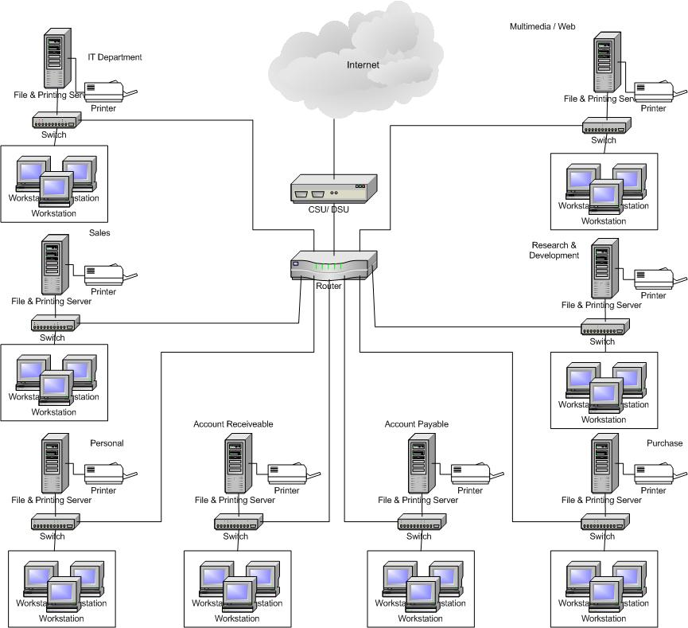

There are 450 users, which are divided evenly among 8 departments. Each department has 56 users. Each workstation is connected in a physical star topology. Each workstation is connected to a 10Mbps switch via UTP Category 3 cable. Each department has their own NT 3.51 server, which has file, print, messaging and ftp services installed. The data travels using CSMA/CD Ethernet methodology.

Each department’s switch is then connected with a router to the T1 connection. The router is then connected to the CSU/DSU to convert the LAN’s signal to the WAN’s signal.

Bull Stock Ticker’s current applications

Name of Application | Type of Application | Number of Users | Department Users
Eurdora | Email application | 450 | For 8 department's users
Norton Antivirus | Virus Detecting application | 450 | For 8 department's users
Netscape 2.0 | Web Browser | 450 | For 8 department's users
Lotus 123 | Spreadsheet application | 450 | For 8 department's users
Lotus Approach | Database | 450 | For 8 department's users
Lotus WordPro | Word application | 450 | For 8 department's users
Lotus Organizer | Organizer application | 450 | For 8 department's users
Acc Pack | Accounting | 112 | Accounting Payable & Receivable
Financial Analyst | Financial application | 112 | Accounting Payable & Receivable
TNM-Logistics 5.12 | Inventory & Sales application | 56 | Sales & Purchase
Netscape Composer | Multimedia | 56 | Multimedia/ Web
Flash | Animation application | 56 | Multimedia/ Web
Macromedia Fireworks | Graphic Editing application | 56 | Multimedia/ Web
Adobe Photoshop | Photo Editing application | 56 | Multimedia/ Web
Hotdog | Web Design application | 56 | Multimedia/ Web
ClipClap 1.0 | Research application | 56 | Research
Net Snippets 2.0 | Research application | 56 | Research
LanFlow | Network Monitoring application | 56 | IT
C++ | Program | 56 | IT
Java / Java Script | Program | 56 | IT
Perl, CGI | Program | 56 | IT

Current Network Protocols

Name of Protocol Type of Protocol No. of users No. of Host/ Service

FTP File Transfer Protocol 450 1

HTTP HyperText Transfer Protocol 450 1

TCP/IP Transmission Control Protocol/ 450 1
Internet Protocol

POP3 Post Office Protocol 450 1

SMTP Simple Mail Transfer Protocol 450 1

SNMP Simple Network Management Protocol 56 1

Potential Bottlenecks

There are eight segments on the network.

Segment1 – IT department
Segment2 – Account Receivable department
Segment3 – Account Payable department
Segment4 – Sales department
Segment5 – Purchasing department
Segment6 – Multimedia & Development
Segment7 – R & D department
Segment8 – Personal department

Segment | Both Source and Destination Are Local | Source Is Local, Destination Is Not Local | Source Is Not Local, Destination Is Local
Segment1 | YES | YES | -
Segment2 | YES | YES | YES
Segment3 | YES | YES | YES
Segment4 | YES | YES | YES
Segment5 | YES | YES | -
Segment6 | YES | YES | -
Segment7 | YES | YES | -
Segment8 | YES | YES | YES

Business Constraints

• Corporate Structure: 8 Departments
• Information flow: Company to client\ Client to company\ Internal Company
• Mission-critical data and operations: Client profile
• The customer has explained any policies regarding approved vendor, protocols, or platforms: the requirement should be posted on network design.
•The customer has explained any policies regarding open versus preparatory solutions: The proposal we supply.
• The customer has explained any policies regarding distributed authority for network design and implementation: IT department is in charge and it will supply training.
• Client’s technical expertise: weak
• Customer’s industry and competition: Among top 100 stock brokerage firm at whole America, and it has branches all over the globe. The competition is intensive; most companies develop the shopping online. Bull Stock Ticker will contain current and develop competition.
• Policies affect network design proposal: Not yet.
• Financial constraints influence the network design: Not yet.

Network Availability

• Hourly cost for a network outage on business time: Unimaginable; the company will destroy if the work don’t prepare correctly. Backup and fault tolerance is extremely essential.
• Hourly cost for a network outage on non-business time: Clients can’t obtain the correct information form the web servers and cause the angry customers who want to buy or sell stocks because of network outage.
• Average MTBF (Mean Time between Failures): 10 hours per month

Network performance
• About the overall network performance, we will refer to the routers, bottleneck, transmission speed and relative network protocols.

Customer requirements

We have assessed that what is needed to improve Bull Stock Ticker’s networking infrastructure to get it to where you want to go is:

- Workstations that are powerful enough to be able to run all of today’s applications
- Workstations that are up-to-date
- Massive storage for customer profile web pages
- Support for client web pages
- Fast and secure backbone
- Support for mobile users
- Reliable backup
- Fast internet, intranet, and extranet
- Servers on secured segments
- Technology so that growth will not affect the company

Design Solution

Proposed network topology

Cost Efficient Model

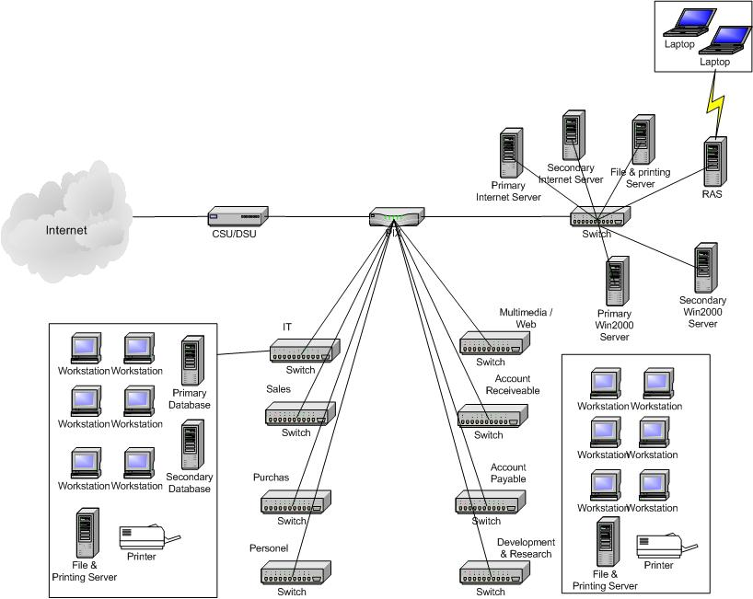

Feature and benefit :

- Cost saving
- Security perform by Cisco firewall
- 1Gbps speed network.
- Redundant centralize servers
- Centralize database and backup
- Remote access service support for mobile users
- OC-3 Internet connection can handle more operation in term of time.

Network Description :

- In the cost efficient model, there is only one internet connection, which is the

OC-3 dedicated line. It is a very high-speed internet connection, its speed can

be up to 155.52 Mbps, which is 10 times faster than the existing T1 connection.

- It is then connected to a Cisco 3725 router, which support OC-3 and has

CSU/DSU built-in. It convert the WAN’s signal to the LAN signals and vice

versa.

- The Cisco 3725 router is connected to a Pix firewall which provide organizations

transparent access for internal and authorized external users, while protecting

internal networks from unauthorized access.

- Next the Pix is connected to a Catalyst 6506 switch, which its backplane capacity

can up to 256 Gbps, in which most of the servers are located in here for high

speed access.

- Catalyst 2948G-L3 is a switch that connect all those 8 switches in each

department. It has the uplink up to a gigabit.

- Eight more Catalyst 4006 switches are employed for each department. It can

support up to 240 workstations. For all the unused port, they can be used for

future upgrade. Since the network topology is designed in star, which all devices

are connected to a central switch. It is easy to install and manage.

- In IT department, central database and backup device are located.
- Each department will have their own workstations, 2 file and print server and 2

laser printer for fast printing.

- For all the IP address, static ip will be employed.

Proposed Network Solution

Cost-Efficient Network Design

The cost-efficient network is a cost saving option for your company. The design

of the whole network is divided into three parts: core, distribution and access layer.

The benefit of such network design provide scalability, easy management and easy

hardware upgrade.

Core Layer

In core layer, it is focused on the WAN implementation, the network core layer is

responsible for the rapid transfer of data and the interconnection of various distribution

and access layers. Therefore the core routers do not have other services that would reduce

the efficiency of the network. In the this layer, we employ Cisco 3725 router which can

support OC-3 Internet connection. Its speed can up to 155.52Mbps which is fast enough

for the expansion growth.

Distribution Layer

The distribution layer serves as the company backbone, it becomes a point in the

network where policy and segregation may be implemented. In this layer, we had all the

servers located in here, such as the internet servers, file and printing server, remote access

servers, the windows 2000 servers, domain name servers and messaging servers. The

design promotes two significant benefits. First, the distribution layer can continue to

function in the event of core failure and the other concerns. Second, it provide simplify

administration work. In this layer, we employ Cisco Catalyst 6506 switch which its

speed can up to 1Gbps.

Access Layer

The access layer ultimate purpose is to interconnect users, workgroups to

backbones, blocking broadcast, and grouping users based on common functions and

services. The access layer is composed of switches or hubs that service a particular floor

of a building or a department within the building. So, we employ Cisco Catalyst

2948G-L3 to interconnect eight Catalyst 4006 switches, which 115 hosts of each

department are connected to it.

Benefit of the solution

- Scalability – provides expansion point without significantly impacting other

portions of the network.

- Easier Implementation – hierarchical model divides the network into logical and

physical sections which the core layer, distribution and access lyers could be

installed independently.

- Easier Troubleshooting – Given the logical layout of the model, hierarchical

designs work to reduce the potential number of loops. Let say if one host of the

network is down, we can easier find the down computer by just looking at the

related switch.

Redundant Model

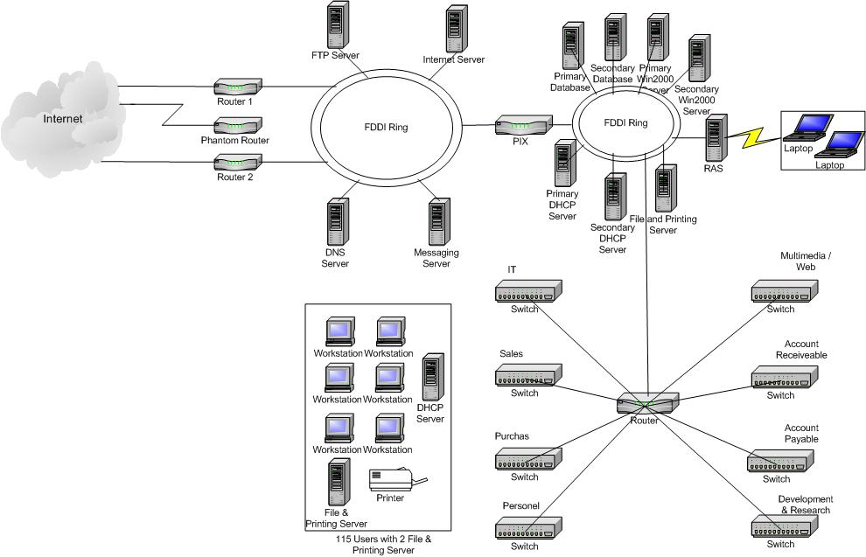

Feature and benefit :

- More reliable in term of redundancy routers, route, media and servers.
- High speed internet connection – OC12.
- Individual DHCP in each departments.
- More robust security made by the 3 part firewall.
- High speed LAN connection.
- Redundant centralize servers.

Network Description :

- In the redundant network, we employ the OC-3 for the WAN connection which

the speed can be up to 155.52Mbps. 2 Cisco 7204VXR routers are employed and

use the hot standby router protocol, which HSRP creates a Hot Standby router

group with a lead router that services all packets sent to the Hot Standby address.

(phantom). The lead router is monitored by other routers in the group, and if it

fails, one of these standby routers inherits the lead position and the Hot Standby

group address.

- The router is connected with FDDI which can support data rate up to 100Mbps.

On the same FDDI network, FTP servers, internet server, DNS and the messaging

servers are located here for all the clients to access.

- Pix firewall is used to protect internal and authorized external users, while

protecting internal networks from unauthorized access.

- All the main servers are located in the second FDDI topology. We employ FDDI

since if one ring network is down, the second ring will keep working. Besides, it

is a very stable network.

- Catalyst 5000 switch is employed to be the main switch device to connect with 8

department’s switches. Since it is a layer 2 and layer 3 device, so it can be

configured as a switch and router as well.

- 4006 is employed for each department’s switch. It can support up to 240 hosts

in the same switch.

Redundant Network Design

The redundant network is a reliable, secure and redundant option for your

company which cost is not vital factor, but still we take it into consideration. The design

of the whole network is also divided into three parts : core, distribution and access layer.

The benefit of such network design provide redundant path, more security and more

scalability to the whole network.

Core Layer

In core layer, it is focused on the WAN implementation, the network core layer is

responsible for the rapid transfer of data and the interconnection of various distribution

and access layers. Therefore the core routers do not have other services that would reduce

the efficiency of the network. In the this layer, we employ two Cisco 7204VXR router

which provide redundant path and fault tolerance in case one of the router goes down, the

internet connection is still available for all the clients and staff to access. Besides, we also

employ the Hot Standby Routing Protocol which provides backup to a router in the event

of failure. Using HSRP, several routers are connected to the same segment of an network

and work together to present the appearance of a single virtual router on the LAN. The

routers share the same IP and MAC addresses, therefore in the event of failure of one

router, the hosts on the LAN are able to continue forwarding packets to a consistent IP

and MAC address. The process of transferring the routing responsibilities from one

device to another is transparent to the user.

Distribution Layer

The distribution layer serves as the company backbone., it becomes a point in the

network where policy and segregation may be implemented. In this layer, we have all the

servers located in here, such as the PIX fireall, internet servers, FTP server, file and

printing server, remote access servers, the windows 2000 servers, domain name servers,

messaging servers, database servers and DHCP servers. FDDI is employed which its

speed can run up to 100Mbps. Although, it is not as fast as the cost-efficient network,

since it consists of 2 rings, it provides redundant media in case one of the ring goes down,

the second one will take over and give the constant and stable access to the whole

network. Cisco Catalyst 5000 switch is used to connect the access layer’s Catalyst 4006

switch in this layer.

Access Layer

The access layer ultimate purpose is to interconnect users, workgroups to

backbones, blocking broadcast, and grouping users based on common functions and

services. The access layer is composed of switches or hubs that service a particular floor

of a building or a department within the building. So, we employ Cisco Catalyst 4006 as

our switches to connect the 115 hosts together in each department since it can support up

to 240 hosts at most. And it runs at 3 different speed which are 10, 100 and 1000Mbps.

And it has a gigabit uplink.

Benefit of the solution

- Scalability – provides expansion point without significantly impacting other

portions of the network.

- Easier Implementation – hierarchical model divides the network into logical and

physical sections which the core layer, distribution and access lyers could be

installed independently.

- Easier Troubleshooting – Given the logical layout of the model, hierarchical

designs work to reduce the potential number of loops. Let say if one host of the

network is down, we can easier find the down computer by just looking at the

related switch.

Hardware and media recommended for the LAN
(See appendixes for specifications)

Main Server

The Dell PowerEdge 6650 is a rack-optimized server used in Internet infrastructure or data

center environments. It’s ideal for business critical computing. It will be used for the

Internet, File and Print, RAS, Windows 2000, DNS and Messaging server.

Database Server
The Dell PowerEdge 6600 is designed for business-critical enterprise systems. It delivers
high levels of availability, scalability and performance. It will be used as a central
database server for the whole company.

File and Print Server

The PowerEdge 2500 is distributed for local and workgroup applications. It provide high

levels performance and availability. It will be the file sharing and printing server in

each department.

Internet Server
The PowerEdge 1650 is a general purpose 1 rack Internet server with high performance.
It includes hot-plug redundant power and cooling, dual channel embedded RAID, and
improved remote management, including dead server management.

Hardware and media recommended for the WAN

To meet the massive growth in the use of the Internet and provide better service to the clients, we provide Hi-Speed Internet access and technical support 24/7 from experts that understand the clients’ business needs. Also through the website we can advertise our service and attract more clients.

Wireless trading is another means of communicating with our clients. We provide wireless versions of Web site to allow clients to access their account via Web-enabled mobile phones and PDAs. No matter where they are, they can manage their trade.

Because a real-time streaming date is critical for the stock trade, we lease two OC-3 serial lines for the Internet connection and one of which is for redundancy purpose. OC-3 uses ATM technology to transmit data over the Internet. Its maximum speed is 155 Mbps. The monthly lease fee for one OC-3 line is $80,000.

Storage Devices

We use to two date servers (300G for each) installed with oracle to manage all clients’ profile, one for backup use.
Price list:
Data servers:
Oracle 9i : $60,000

IP Addressing

Before we introduce the IP Addressing Plan , we should give you a brief introduction about IP addressing and subnetting. IP addresses are 32 bits, which 8 bits are combined as one group named Octets. And 4 groups are separated by dots, and represented, in decimal format. As in all network layer addresses, part of a device’s address represents the network, and part identifies the host number that this device is on that network. IP networks can also be subdivided into sub-networks. Subnet mask defines which or which part of octets is network and which part is host.

IP addressing defines five address classes: A, B, C, D and E. Only A, B and C are available for IP assigned. Class A ranges from 1.0.0.0 to 126.0.0.0, Class B ranges from 128.0.0.0 to 191.0.0.0, Class C ranges from 192.0.0.0 to 223.0.0.0

The assigned IP address of Bull Stock domain is 148.26.0.0. It is a class B address. Theoretically, without subnetting a Class B IP address can be attached by 65534 hosts within one big network, but this kind of design will decrease the speed of network transmission and cause effectiveness. In order to avoid this situation, we will subdivide the Class B IP address to subnets and distribute them to each department and on each subnet or segment can be attached with a smaller number of hosts.

Considering the efficiency and expandability, here is our solution: divide the whole network into 254 subnets and each subnet can support 254 hosts, and subnet mask is 255.255.255.0. IP addressing plan is shown with following table:

Network IP Address | Valid assigned IP address range
148.26.1.0 | 148.26.1.1-148.26.1.254
148.26.2.0 | 148.26.2.1-148.26.2.254
148.26.3.0 | 148.26.3.1-148.26.3.254
148.26.4.0 | 148.26.4.1-148.26.4.254
148.26.5.0 | 148.26.5.1-148.26.5.254
148.26.6.0 | 148.26.6.1-148.26.6.254
148.26.7.0 | 148.26.7.1-148.26.7.254
148.26.8.0 | 148.26.8.1-148.26.8.254

File and printing server | DHCP Server | Switch and Router | Workstations
148.26.1.4-148.26.1.5 | 148.26.1.3 | 148.26.1.1-148.26.1.2
148.26.2.3-148.26.2.4 | 148.26.2.2 | 148.26.2.1
148.26.3.3-148.26.3.4 | 148.26.3.2 | 148.26.3.1
148.26.4.3-148.26.4.4 | 148.26.4.2 | 148.26.4.1
148.26.5.3-148.26.5.4 | 148.26.5.2 | 148.26.5.1
148.26.6.3-148.26.6.4 | 148.26.6.2 | 148.26.6.1
148.26.7.3-148.26.7.4 | 148.26.7.2 | 148.26.7.1
148.26.8.3-148.26.8.4 | 148.26.8.2 | 148.26.8.1

Routing and bridging protocols recommended for the network

NAT stands for Network Address Translation. Now the internet is expanding at exponential rate. As the information and resources increase, NAT is becoming a requirement for the small business and homes to connect to internet. It’s a method to connect multiple computers to internet by using one IP address. This allows home users and small business to connect their network to the internet cheaply and efficiently.

There are three reasons for why we use the NAT:
- World storage of IP address
- Security needs
- Ease and flexibility network administration

Redundancy model:

The routing protocol we use the HSRP. HSRP stands for Hot Standby Router Protocol. It main function is to provide a way for IP workstations to keep their communication on the internet even though their default router is failed. HSRP works by creating a phantom router that has its own IP address and MAC address and workstations look it as default router. Two routers will be selected from a set of routers running HSRP, one is active router, another one is called standby router. The active router period sends hello messages to other HSRP routers. Once the active router is failed, other HSRP routers stop receiving hello messages, the standby router takes over to become a new active router. Because it has both IP and MAC addresses of phantom router, so end nodes continue to send packets to the phantom router’s MAC address and the new active router deliver those packets.

Cost-efficient model:
In order to decrease the traffic on network, the router may filter out some broadcast and then connect to the PIX (firewall); PIX also can filter out some packets that the router may not have caught.

Software features recommended for the network

The new software and operating systems that we plan on implementing in the company are:

Windows 2000 – An operating system built on NT technology, incorporates added security for workstations

Linux Red Hat – a unix based operating system. A great backbone with added security.

MSOffice 2000 – with such features as Access, Excel, Word and Powerpoint
Netscape – internet browser
Internet Explorer – internet browser

MSFrontPage 2002 – web site creation and management tool
MSProject 2002 – a project management tool. Helps organization and efficiency of projects.
VISIO 2002 Enterprise – a diagram/flowchart program
Auto CAD 2002 – drafting software
Macromedia Flash 4 – multimedia to help in producing interactive images
Shockwave Director – create and edit moving images
Adobe Distiller – server software
Photoshop – editing tool for pictures
3D Studio Max R3 -
Bryce -
Simply Accounting – accounting software to help with the ease of organizing financial records

Appendixes
Securtiy
Computer and network security is a complex world, and growing more so every day. With these changes, some truths and approaches to security remain the same, while others are new and radically different.

Even though there are many different kinds of security to choose from. We have chosen to implement a Three-part Firewall System. The typical setup will look as follow:

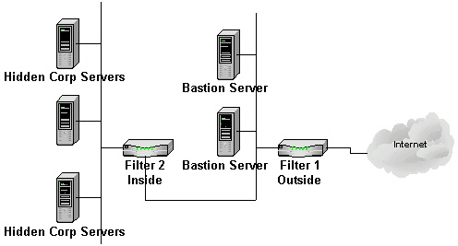

Filter 1 Part:
These device will be used for authentication of the users who have the right privileges to the bastion servers and any an authorized person will not have access to bastion servers. In our case the bastion servers will contain the information for the outside world, which will be the web servers.

Cisco PIX 535 Firewalls
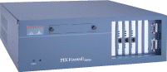
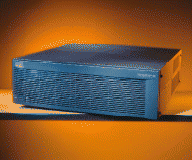

Features of PIX 535
- Cleartext throughput: 1.0 Gbps
- Concurrent connections: 500,000
- Connections per second: 7,000
- 168-bit 3DES IPsec VPN throughput: 100 Mbps
- Simultaneous VPN tunnels: 2,000
- Processor: 1.0-GHz Intel Pentium III
- Random Access Memory: 512 MB, or 1 GB of SDRAM (Registered PC133)
- Flash Memory: 16 MB
- Cache: 256 KB level 2 at 1 GHz
- System BUS: Dual 64-bit, 66-MHz PCI; Single 32-bit, 33-MHz PCI
- Filter 2 Part:

Filter 2 will consist on PIX 535 Firewall. This section is where all the internal servers of the company are located. The only users who will have access to these servers are the company users.

Features of PIX 535 once again
- Cleartext throughput: 1.0 Gbps
- Concurrent connections: 500,000
- Connections per second: 7,000
- 168-bit 3DES IPsec VPN throughput: 100 Mbps
- Simultaneous VPN tunnels: 2,000
- Processor: 1.0-GHz Intel Pentium III
- Random Access Memory: 512 MB, or 1 GB of SDRAM (Registered PC133)
- Flash Memory: 16 MB
- Cache: 256 KB level 2 at 1 GHz
- System BUS: Dual 64-bit, 66-MHz PCI; Single 32-bit, 33-MHz PCI

These are the comparison between the two firewalls which will be implementing one is the minimum (PIX 525 Firewall) , the second optimum (PIX 535 Firewall)

Description | PIX 525 Firewall | PIX 535 Firewall
Processor | 350 MHz | 1 GHz
RAM | 128 MB or 256 MB | 512 MB or 1 GB
Flash Memory | 16 MB | 16 MB
PCI Slots | 3 | 9
Fixed Interfaces | 2 10/100 Fast Ethernet | None
Maximum Interfaces | 8 10/100 Fast Ethernet or Gigabit Ethernet | 10 10/100 Fast Ethernet or Gigabit Ethernet
VPN Accelerator Card (VAC) Support | Yes | Yes
Failover Support | Yes, UR only | Yes, UR only
Rack Mountable | Yes | Yes
Size | 2 RU | 3 RU

With CyberWallPLUS each server has its own firewall in addition to the enterprise's greater firewall, ensuring that if one server's security is breached, it doesn't bring down the entire network. Its built-in intrusion detection capability was another attractive feature to why we recommend this product.
Aside from the server each workstations will also have Norton Anti Virus 2002 installed for virus protection.

Price

Note: PIX 535 (2) Total Price $79500
CyberWallPLUS $1000 for 30 License (calculate to how many users there are and how many license they will need.)
Norton Anti Virus 2002 $6520 for 1 CD with 200 License (calculate to how many users there are and how many license they will need.)

Cost effective:
PIX 525 (2) Total Price $72588

Backup and Restore

Although backups are time consuming, difficult and tedious, they are necessary evils with today's technology. Because today's personal computers are so reliable, you may be lulled into a false sense of security. Make no mistake hard drives crash, viruses can infect your system and destroy your data, human error can reek havoc on your business, and a thief can simply steal your computer and it's data goes with it!

The Backup and Restore software will be VERITAS NetBackup DataCenter the industry's leading enterprise data protection solution for UNIX, NT and NetWare environments that provides fast, reliable data-centre strength backup and recovery to protect environments that span terabytes to petabytes in size.VERITAS NetBackup DataCenter provides the most comprehensive media management support available with the broadest coverage for all major tape libraries from vendors such as STK, AIT, IBM, ATL and ADIC. VERITAS NetBackup DataCenter's complete media management capabilities are built into the base product and include tape labeling, tape media pool creation, reporting capabilities and bar code support.
The Exabyte X80 accommodates from two to eight M2 or Mammoth tape drives and from 40 to 80 data cartridges. All Exabyte libraries feature the industry's most advanced and durable robotics system as well as a user-friendly interface and modular design.
Exabyte libraries are seventh-generation products that consistently demonstrate the highest levels of reliability and software compatibility. Their use can cut data management cost and time by 50 percent.

FEATURE | BENEFIT
Field upgradable | Protects customer investment
Rack and standalone configurations | Provides configuration flexibility
Laser bar code scanner | Reduces media inventory time and improves file management
Front access | Direct access to drives and media improves serviceability
Enhanced LCD display | Menu-driven interface provides easy operation and supplies user with instant library status
Multi-drive capability | Increases throughput, permits concurrent operation.  Allows fault tolerance
Removable magazines | Facilitates off-line storage, loading of library
5-cartridge entyr/exit port | Access to cartridges without interupting library operations
Standard ethernet port | Allows for browser-based library management
Exabyte 440/480 & X80 emulation | Supports a broad range of software applications

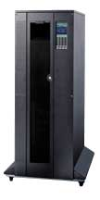
Price
$43,221.00

Cost effective
Exabyte X80 Mammoth-2 Tape Lib LVD 40slot/6TB | Rack, black, 2 drives (expandable to 8), 40 slots (expandable to 80), bar code scanner, Ethernet port, Entry/Exit port, power cord, Installation and Operation Manual, Monitor Software, 2m, 1m, and 15" cables, terminator. LVD wide & 68-pin connector.

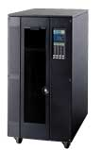
$37,155.

Main Servers for Cost-Efficient Model

Dell PowerEdge 6650

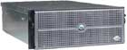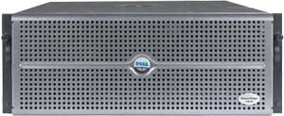

The PowerEdge 6650 is a rack-optimized server used in Internet infrastructure or data

center environments. It’s ideal for business critical computing. It will be used for the

Internet, File and Print, RAS, Windows 2000, DNS and Messaging server.

Features
- Designed for running business-critical applications that need scalable
performance and redundant feature.
- Up to 4 Intel Xeon Processors running at 1.4GHz, 1.5GHz and 1.6GHz, with
level 3 cache.
- Fast and reliable with its speed and RAID function.

Specification
Processors | PowerEdge 6650, Intel Xeon 1.4GHz w/512K Cache, Redundant Power.
Additional Processors | 2 PowerEdge 6650 Intel® 1.4GHz XeonTM
Memory | 4GB DDR SDRAM, 8X512MB DIMMs
Cache | 512KB L3 Cache
Storage | (73GB x 5) 365GB¹ 10K RPM, 1in Ultra3 (Ultra 160) SCSI Hot Plug Hard Drive
RAID | RAID 5
Primary and Secondary Controller | PERC3-DC, 128MB, 2 Internal Channels
Network Controller | 2 integrated 10/100/1000 Ethernet adapter
Chassis Configuration | Rapid Rails for Dell Rack, P6650
Spare Power Supply | Cold Spare Power Supply, PE6650
Input Devices | Windows keyboard
Mouse | Microsoft System Mouse,Gray
Monitor | Dell P793,17in (16.0in Viewable),Gray Monitor
CD ROM or DVD ROM | 24X IDE Internal CD ROM Drive
Ports | PS/2 keyboard, PS/2 mouse, serial, video ports, 2 USB connectors, 2 RJ45.
Remote Management | Dell Remote Access Card, Version III, with Modem
Hardware Support Service | 3Yr SILVER Support, 4Hr Onsite, S/W Support
Operating System | Windows 2000 Server

Cost : CAD27,042.00

Database Server

Dell PowerEdge 6600

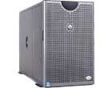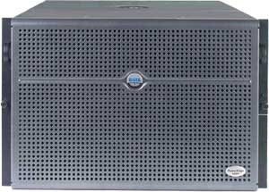

Dell PowerEdge 6600is designed for business-critical enterprise systems. It delivers
high levels of availability, scalability and performance. It will be used as a central
database server for the whole company.

Features
- Up to 4 Intel® XeonTM processors MP at 1.4GHz, 1.5GHz, and 1.6GHz.

- 7U rack-optimized configuration giving this server a high degree of configuration and deployment flexibility.

- It is great for business critical application and database.

- Redundant power supplies

Specification
Base Processors | PowerEdge 6600, Intel Xeon 1.4GHz w/512K Cache, Redundant Power
Additional Processors | 2 Processor Intel Xeon, 1.4GHz w/512K Cache, Redundant Power
Memory | 8GB DDR SDRAM, 16X512MB DIMMs
Cache | 256KB L2 cache and 512KB L3 cache.
Storage | (73GB x 5) 365GB 10K RPM, 1in Ultra3 (Ultra 160) SCSI Hot Plug Hard Drive
RAID | RAID 5
Primary Controller | PERC3-DC, 128MB, 1 Internal, 1 External Channels
Secondary Controller | PERC3-DC, 128MB, 2 External Channels
Network Controller | 2 integrated 10/100/1000 Ethernet adapter.
Chassis Configuration | Rapid Rails for Dell Rack, P6600
Spare Cooling Fans | Cold Spare Fan, PE66X0
Spare Power Supply | Cold Spare Power Supply, PowerEdge 6600
Input Devices | Windows keyboard
Mouse | Microsoft System Mouse,Gray
CD ROM or DVD ROM | 24X IDE Internal CD ROM Drive
Monitor | Dell P793,17in (16.0in Viewable),Gray Monitor
Ports | PS/2 keyboard, PS/2 mouse, 1 serial, 2 USB, video ports, and external 68-pin Ultra3 (Ultra160) SCSI VHDC connector
Hardware Support | 3Yr SILVER Support, 4Hr Onsite, S/W Support
Software | Windows 2000 Server
Cost : CAD29,100.00

File and Print Server

PowerEdge 2500

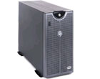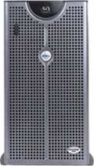

PowerEdge 2500 is distributed for local and workgroup applications. It provide high

levels performance and availability. It will be the file sharing and printing server in

each department.

Features

- Up to 2 Intel® Pentium® III processors

- Features 5U rack-capable tool-less chassis to deliver enhanced serviceability and

rack space conservation.

- Includes RAID controller with 128M battery-backed cache for superb

performance and data protection.

Specification
Base Processors | PowerEdge 2500 Intel Pentium III 1.0GHz w/256K Cache
Additional Processors | 2nd Processor 1.0GHz w/256K Cache
Memory | 1GB SDRAM, 133 MHz, 4X256MB DIMMs
Cache | 256K Cache
Storage | (36GB x 2) 72GB 15K RPM Ultra 160 SCSI Hard Drive
Primary Controller | PERC3-DI, 128MB, 2 Internal Channels - Embedded RAID
RAID | RAID 1
Network Controller | integrated 10/100 Ethernet adapter
Chassis Orientation | Tower Chassis
Input Devices | Windows keyboard, Dell PS/2-style mouse
CD ROM or DVD ROM | 24X, IDE CD-ROM
Monitor | Dell P780, 17 in (16.01 in Viewable), Gray
Mouse | Microsoft System Mouse,Gray
Ports | 2 USB ports
Hardware Support Service | 3Yr SILVER Support, 4Hr Onsite, S/W Support
Operating System | Microsoft Small Business Server 2000 wit
Cost : CAD7,726.00

Internet Server

PowerEdge 1650

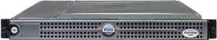

The PowerEdge 1650 is a general purpose 1 rack Internet server with high performance.
It includes hot-plug redundant power and cooling, dual channel embedded RAID, and
improved remote management, including dead server management.

Feature
- High performance in an ultra-thin 1U form-factor.

- Single or dual Intel® Pentium® III processors up to 1.4GHz for expandable
performance.
- Support up to 219GB internal storage capacity and up to 4GB of 133MHz ECC
SDRAM for internal expansion.
- 3 hot-swappable hard drive bays allow for a RAID 5 configuration in a 1U server.

Specification
Base Processor | PowerEdge 1650,Intel Pentium III,1.13GHz w/512K Cache
Additional Processor | Dual Processor Intel Pentium III,1.13GHz w/512K Cache
Memory | 2GB SDRAM,133MHz,4X512MB DIMMs
Storage | (73GB x 2) 73GB 10K RPM Ultra 160 SCSI Hard Drive
Primary Controller | PERC3-DI,128MB Battery Backed Cache,1 Int,1 Ext Channels- Embedded RAID
Chassis Configuration | RapidRails for Dell Rack
Power Source | AC Power Option for Dell PowerEdge 1650
First Network Adapter | Broadcom NetXtreme 10/100/1000-Copper
Second Network Adapter | Intel Pro 1000XT Gigabit NIC-Copper
Monitor | Dell P793,17in (16.0in Viewable),Gray Monitor
Input Device | Standard Windows Keyboard,Gray, Mouse
CD ROM | 24X IDE Internal CD ROM Drive
Hardware Support Service | 3Yr SILVER Support, 4Hr Onsite, S/W Support
Operating System | PowerEdge Web Server - Powered by Red Hat Linux
Cost : CAD9,183.00

Server for Redundant Model

Dell PowerEdge 6600

Dell PowerEdge 6600 is designed for business-critical enterprise systems. It delivers high
levels of availability, scalability and performance. It is used for the Internet, FTP, DNS
and Messaging Server.

Features
- Up to 4 Intel® XeonTM processors MP at 1.4GHz, 1.5GHz, and 1.6GHz.

- 7U rack-optimized configuration giving this server a high degree of configuration
and deployment flexibility.
- It is great for business critical application and database.

- Redundant power supplies

Specification
Base Processors | PowerEdge 6600, Intel® Xeon 1.4GHz, with Redundant Power
Additional Processors | 4 Processor Intel® Xeon, 1.4GHz with 512K Cache
Memory | 12GB DDR200 ECC SDRAM.
Cache | 1.4GHz and 1.5GHz processors with 256KB L2 cache and 512KB L3 cache; 1.6GHz processor with 256KB L2 cache and 1MB L3 cache.
Storage | (73GB x 8) 584GB 10K RPM, 1' Ultra3 (Ultra 160) SCSI Hot Plug Hard Drive
RAID | RAID 5
Primary and Secondary Controller | PERC3,DC,128MB,2-INT,0-EXT CHANNELS
Chassis Style | Rapid Rails for Dell Rack, P6600
Power Switch or Power Pass Thru | AC Switch (dual cords) for Dual Power Sources
Spare Power Supply | Cold Spare Power Supply, PowerEdge 6600
Spare Fan | Cold Spare Fan, PowerEdge 66X0
Network Adapter | 2 integrated 10/100/1000 Ethernet adapters
Second Network Adapter | Intel Pro 1000F (Fiber)
Input Devices | Windows keyboard, Microsoft Mouse
Monitor | 17" P793
CD ROM | 12x24 Slim CD-ROM
Hardware Support Service | 3Yr SILVER Support, 4Hr Onsite, S/W Support
Operating System | Red Hat Linux 2.1 Advanced Server with Documentation and Media

Cost : CAD39,508.00

Internal Servers

PowerEdge 4600

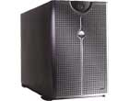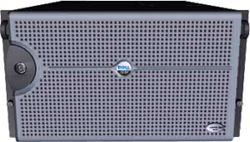

The PowerEdge 4600 is designed with features to help provide continuous operation,
high availability, and excellent data protection. It is used for Database, File and Print,
Windows2000, RAS, and DHCP server.

Features
- Extreme Expandability - The PowerEdge 4600 can accommodate 10 hard drives for up to 730GB internal storage capacity

- Support 12GB of memory.

- Dual embedded Ethernet controllers (one is Gigabit) and two embedded SCSI

controllers.
- 6 rack chassis maximum.

Specification
Base Processors | PowerEdge 4600,Intel Xeon 1.8GHZ/512K Cache
Additional Processors | 2nd Processor,Intel Xeon 1.8GHZ/512K Cache
Memory | 12GB DDR SDRAM 12X1GB
Cache | 512K Cache
Storage | (73GB x 8) 584GB 10K RPM Ultra 160 SCSI Hard Drive
RAID | RAID 5
Primary Controller | PERC3-DC Card,128MB,2-Internal,0-External Channels
Secondary Controller | PERC3-DC Card,128MB,0-Internal,2-External Channels
Network Controller | Intel 100 Dual Port Network Adapter
Chassis Style | RapidRails for Dell Rack
Power Supply Kit | Redundant Power Supplies
Remote Access Card | Dell Remote Access Card, Version III, with Modem
Modem | Dell Remote Assistant Card 2.0
Input Devices | Windows keyboard, Mouse
Monitor | P793, 17in (16.01VIS) Monitor, MGray
CD ROM and DVD ROM | 24X IDE CD-ROM
Hardware Support Service | 3Yr SILVER Support, 4Hr Onsite, S/W Support
Operating System | Windows 2000 Advanced Server.

Cost : CAD95,554.50

DHCP and File and Print Server in departments

PowerEdge 2500

PowerEdge 2500 is distributed for local and workgroup applications. It provide high

levels performance and availability. It will be the file sharing and printing server in

each department.

Features

- Up to 2 Intel® Pentium® III processors

- Features 5U rack-capable tool-less chassis to deliver enhanced serviceability and

rack space conservation.

- Includes RAID controller with 128M battery-backed cache for superb

performance and data protection.

Specification
Base Processors | PowerEdge 2500 Intel Pentium III 1.0GHz w/256K Cache
Additional Processors | 2nd Processor 1.0GHz w/256K Cache
Memory | 1GB SDRAM, 133 MHz, 4X256MB DIMMs
Cache | 256K Cache
Storage | (36GB x 2) 72GB 15K RPM Ultra 160 SCSI Hard Drive
Primary Controller | PERC3-DI, 128MB, 2 Internal Channels - Embedded RAID
RAID | RAID 1
Network Controller | integrated 10/100 Ethernet adapter
Chassis Orientation | Tower Chassis
Input Devices | Windows keyboard, Dell PS/2-style mouse
CD ROM or DVD ROM | 24X, IDE CD-ROM
Monitor | Dell P780, 17 in (16.01 in Viewable), Gray
Mouse | Microsoft System Mouse,Gray
Ports | 2 USB ports
Hardware Support Service | 3Yr SILVER Support, 4Hr Onsite, S/W Support
Operating System | Microsoft Small Business Server 2000 wit
Cost : CAD7,726.00

Cost

Software Price Breakdown by Department

- IT Department

Software | Quantity | Individual Price | Total
Adobe Distiller | 12 | $5,000 | $60,000
MSProject | 20 | $472 | $9,440
Windows 2000 Pro | 56 | $319 | $17,864
Linux Red Hat Advanced Server | 10 | $799 | $7,990
 |  | Total | $95,294

- Accounts Payable and Accounts Receivable Departments

Software | Quantity | Individual Price | Total
AccPac Simply Accounting | 20 | $725 | $14,500
Windows 2000 Pro | 56 | $319 | $17,864
 |  | Total | $32,364

- Sales Department

Software | Quantity | Individual Price | Total
AccPac Simply Accounting | 20 | $725 | $14,500
Windows 2000 Pro | 56 | $319 | $17,864
 |  | Total | $32,364

- Purchasing Department

Software | Quantity | Individual Price | Total
AccPac Simply Accounting | 20 | $725 | $14,500
Windows 2000 Pro | 56 | $319 | $17,864
 |  | Total | $32,364

- Multimedia/Web Development Department

Software | Quantity | Individual Price | Total
Adobe Photoshop | 56 | $609 | $34,104
Macromedia Flash MX | 56 | $299 | $16,744
MSProject 2002 | 20 | $472 | $9,440
Windows 2000 Pro | 56 | $319 | $17,864
MSFrontpage | 56 | $169 | $9,464
Shockwave Director | 30 | $1199 | $35,970
 |  | Total | $123,586

- Research and Development Department

Software | Quantity | Individual Price | Total
Visio 2002 Pro | 56 | $394 | $22,064
AccPac Simply Accounting | 20 | $725 | $14,500
Windows 2000 Pro | 56 | $319 | $17,864
 |  | Total | $54,428

Software Price Totals

IT Department | $95,294
Accounts Payable | $32,364
Accounts Receivable | $32,364
Sales | $32,364
Purchasing | $32,364
Research & Development | $54,428
Multimedia/Web Development | $123,586
Personnel
Total | $402,764

Network Connectivity Breakdown

- Servers

Cost Efficient Server | Unit | Price
Dell PowerEdge 6650 | 1 | CAD27,042.00
Dell PowerEdge 6600 | 1 | CAD29,100.00
Dell PowerEdge 2500 | 8 | CAD61,818.00
Dell PowerEdge 1650 | 1 | CAD9,183.00
 | Total | CAD127,143.00

Redundant Server | Unit | Price
Dell PowerEdge 6600 | 1 | CAD39,508.00
Dell PowerEdge 4600 | 1 | CAD95,554.50
Dell PoweEdge 2500 | 16 | CAD123,616.00
 | Total | CAD258,678.50

- Routers

Software | Quantity | Individual Price | Total

- Switches

Software | Quantity | Individual Price | Total

Appendix

FTP – A protocol to transfer data from one host to another computer.

HTTP – Request / response protocols that enable a user to view resources stored on the web.

TCP/IP – A suite of protocol that allows connectivity between heterogeneous environment.

POP3 – A protocol used by email clients to retrieve email messages from a server using TCP as
the transport protocol.

SMTP – A protocol provides mail transfer two hosts.

SNMP – An applications-level protocol that allows for management of network devices
including routers, hubs and switches.

CSMA/CD - Carrier sense multiple access with collision detection. A station listens to the
physical network to determine whether another host is currently transmitting data
on the network. If a collision occurs, the sending stations must wait a random
period of time before attempting to retransmit.

CSU – A channel service unit / data service unit converts network data into digital bipolar signals that are able to traverse a synchronous communications environment.

T1 – A digital line service that provides transmission rate of up to 1.544Mbps. It can carry both voice and data transmission.

Hub
A network connectivity device that brings media segments together in a central
location. It is the central controlling device in some star network. It contains multiple ports.
When a packet arrives at one port, it is copied to the other ports so that all segments of
the LAN can see all packets.

Switch
In networks, a device that filters and forwards packets between LAN segments.

Each port on the switch is a dedicated LAN segment with dedicated bandwidth offered

to attached devices. Each port on the LAN switch may be assigned to a single

workstation. The advantage switch is dedicated connections and guaranteed bandwidth

within the there switched LAN architecture itself. Besides, it can interconnect LANs of

unlike bandwidth; a 10-Mbps Ethernet LAN and a 100-Mbps Ethernet LAN, can be

connected using a switch.

Router
A device that connects any number of LANs. Routers use headers and a
forwarding table to determine where packets go, and they use ICMP to communicate with
each other and configure the best route between any two hosts. It segment LANs and
WANs. It can figure out the best way to send data to its destination. It can also talk to
other routers to learn from them and tell them what it knows in order to route the packet
to the designated network.

